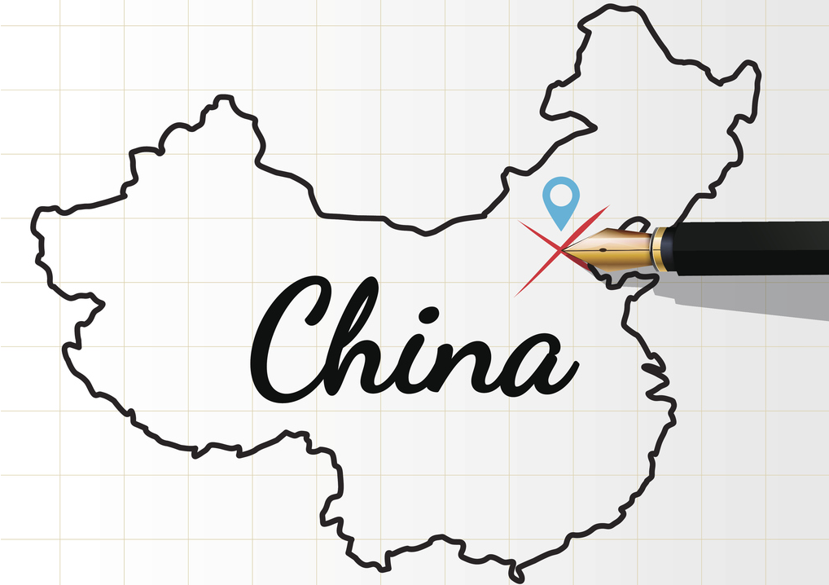

SGROUP THINK TANK FOR CHINA KICK-OFF MEETING

4-5 May, Lisbon

Senate Room
REITORIA DA UNIVERSIDADE NOVA DE LISBOA
Campus de Campolide • 1099-085 Lisboa • Portugal

INTRODUCTION
The SGroup Network is organising the Kick-off Meeting of the SGroup Think Tank for China to be held in at the NOVA Universidade de Lisboa on 4-5 May 2017 to which we are pleased invite in particular members of the Think Tank for China and representatives of the SGroup universities interested in the EU-China relations. The participants of the Kick-off meeting are also welcome to attend the Europe-China Rectors' Seminar organised by the LEAD Project partnership and hosted by Universidade NOVA de Lisboa on 5th May 2017.

The Think Tank for China was created at the General Assembly 2015 in Las Palmas de Gran Canaria with a general objective to explore new avenues of collaboration with China in a structured and systematic way by bringing into life the Think Tank for China (TT4C).

This group is composed of experts from SGroup member universities as well as other institutions with specific expertise on China who are willing to exchange their experience and to capitalize on their contacts established in China to extend global outreach of our members in education, research, and services. With this aim in mind we intend to:

- create a Sustainable Institutional Network with selected Chinese and SGroup universities;

- set up an information hub about co-operation opportunities with China thanks to the pool of experts from individual member institutions;

The first meeting of the Think Tank is intended to discuss in further details existing capacity in our network for a structured collaboration with China, common fields of expertise, needs analysis in the network and decide on the priorities accordingly. The event coincides with a very important initiative driven by the EU Erasmus+ Capacity Building LEAD project: Governance and Academic Leadership of Chinese and European Universities in the Context of Innovation and Internationalisation, coordinated by Vrije Universiteit Brussel.

The Seminar will bring together representatives of academic leadership from UNICA member universities, their counterparts from more than 50 top Chinese HEIs, as well as senior officials from the European Commission and the Chinese Mission to the EU to discuss the future of academic cooperation between Europe and China. The event is jointly organised by UNICA, Universidade NOVA de Lisboa and the LEAD coordinator VUB. The Rectors' Seminar is also supported by the Mission of the People's Republic of China to the European Union under the framework of the EU-China High Level People-to-People Dialogue (HPPD).

TARGET AUDIENCE

Members of the Think Tank for China, Rectors/Presidents, Vice-Rectors/Vice-Presidents, Heads of Research and International Relations Offices. Senior International Relations Officers and Advisors working on university cooperation with China are also welcome to attend the event.

REGISTRATION

PLEASE NOTE that the events, although both address to the SGroup members, they are organised separately, hence it’s necessary for all participants to fill in TWO online forms available below:

- REGISTRATION for the SGroup Think Tank for China Workshop on 4th May available HERE

- REGISTRATION for Europe-China Seminar on 5th May available HERE

After submitting your form, you will receive an email acknowledging receipt of your submission. If you encounter any problems with the submission or have any questions related to your participation, do not hesitate to contact Wioletta Węgorowska (wioletta.wegorowska@sgroup.be) for the Kick-off Meeting or Marta Brelih-Wasowska from the UNICA Secretariat (marta.wasowska@unica-network.eu) for the Rectors' Seminar.

ACCOMMODATION

The month of May marks the start of high tourist season in Lisbon and many hotels in Lisbon are already booked for the visit of the Pope to Portugal (starting in the week following the Seminar), we strongly recommend that participants secure their accommodation at their earliest convenience.

Recommended Hotels are as follows:

- Hotel Corinthia Lisbon (walking distance)
- Mercure Lisboa Hotel (walking distance)
- NOVOTEL Av. José Malhoa (walking distance)
- Hotel Ibis José Malhoa (walking distance)
- Hotel Acores Lisboa (longer walk)
- Hotel Real Parque Lisboa (longer walk)
- Hotel Ibis Lisboa Liberdade (20 min by metro)

TENTATIVE AGENDA
4th May
9.00-12.30 I working session
12.30-13.30 Lunch
13.30-15.00 II working session
15.00-15.30 Coffee break
15.30-17.10 Special session within the framework of the Europe-China Rectors’ Seminar
The session is organised DG EAC of the European Commission and it will focus on funding of the collaboration with China. It will be chaired by Vito BORRELLI, Head of Sector Jean Monnet & China Desk, DG Education and Culture, European Commission.

20.00 Networking dinner
5th May
The Programme of the Europe-China Rectors’ Seminar is available at this LINK

USEFUL LINKS:
LEAD PROJECT: http://lead-project.org/
SGROUP THINK TANK FOR CHINA WEBSITE: http://sgroup.be/news/sgroup-think-tank-china-kick-meeting
EUROPE-CHINA RECTORS’ SEMINAR EVENT http://lead-project.org/event/3rd-series-of-lead-workshops-finland-and-p...
SPEAKERS AT THE EUROPE-CHINA SEMINAR http://www.unica-network.eu/sites/default/files/lead_rectors_seminar_meet_the_speakers.pdf

